Gwaii Hanaas Acoustic Recording Study Design Recommendations 2019

Thorley, J.L.

2019-03-15

The suggested citation for this [analytic report](http://www.poissonconsulting.ca/analytic-reports.html) is:

Thorley, J.L. (2019) Gwaii Hanaas Acoustic Recording Study Design Recommendations 2019. A Poisson Consulting Analysis Report.

## Background

Gwaii Hanaas team members are required to monitor the status of specific ecological field measurement through time (Parks Canada Agency 2011). The recording of the measurements should follow a strict protocol, ie be repeatable, and where feasible should ideally provide local ground-based measures as well as landscape-scale measures often using remote sensing tools.

A measurement that fits the description provided is the use of Acoustic Recording Units (ARUs) to record bird song and bat calls and other terrestrial sounds. Although simple to collect, the limitations on resources combined with the large amount of data recorded and time required to process the raw sound files necessitate careful consideration of which data should be collected, where that data should be stored and how it should be processed and eventually analysed.

The objectives of the current study were to

* Adjust the study design and develop an appropriate monitoring question for the measure, based on the recommended sampling design and sampling frame.
* Re-design and write the ‘sampling design’ section of the monitoring protocol as appropriate.
* Provide recommendations on how to proceed with similar measure analyses and protocol design for the other 3 ARU measures for Gwaii Haanas.

This reviews the current scientific literature and builds on existing reports including those on Northern Saw-Whet Owl (*Aegolius acadicus brooksi*) by Carl Schwarz (2018a, 2018b) to provide recommendations on all aspects of study design.

## Data Life Cycle

As discussed by Michener and Jones (2012), ecology is increasingly becoming a data-intensive science relying on massive amounts of data collected by both remote-sensing platforms and sensor networks that are embedded in the environment. They define ecoinformatics as a framework that enables scientists to generate new knowledge through innovative tools and approaches for discovering, managing, integrating, analyzing, visualizing and preserving relevant biological, environmental, and socioeconomic data and information.

Strasser et al. (2011) describe the eight steps in the data life cycle as follows

1. **Plan**: description of the data that will be compiled, and how the data will be managed and made accessible throughout its lifetime
2. **Collect**: observations are made either by hand or with sensors or other instruments and the data are placed a into digital form
3. **Assure**: the quality of the data are assured through checks and inspections
4. **Describe**: data are accurately and thoroughly described using the appropriate metadata standards
5. **Preserve**: data are submitted to an appropriate long-term archive (i.e. data center)
6. **Discover**: potentially useful data are located and obtained, along with the relevant information about the data (metadata)
7. **Integrate**: data from disparate sources are combined to form one homogeneous set of data that can be readily analyzed
8. **Analyze**: data are analyzed

This reports discusses each step in turn. Although it focuses on Northern Saw-Whet Owls (NSWOs), the general principles are applicable to other species.

### 1. Collect

#### Power

An aim of any study design is to ensure sufficient data can be collected to answer the questions of interest with acceptable levels of uncertainty.

A power analysis by Schwarz (2018b), indicates that assuming an occupancy probability of between 0.6 and 0.7 and a detection probability per night of about 0.2, the optimal number of nights to survey ranges from 10 to 11 (ignoring survey costs). However given that the cost of increasing the recording period is minimal, a recording period of 120 minutes (1 hour in each period) for 14 days will give a detection probability very close to 100%. However, even with a recording period of 120 minutes for 14 days at each site, there is little chance of detecting a 10% decline even over 10 years with 200 sites sampled per year! With the current limitation of 20 sites/years, only a 50% change over 10 years can be reliably detected if random occupancy is occurring.

The above power calculations ignores year to year fluctuations due to ecological factors (process error) and assumes the birds represent a single population. If there is substantial process error, then sampling more sites in year will not be helpful (Schwarz 2018b). If there are two populations and both are monitored, then the number of sites needs to be doubled to achieve the same power.

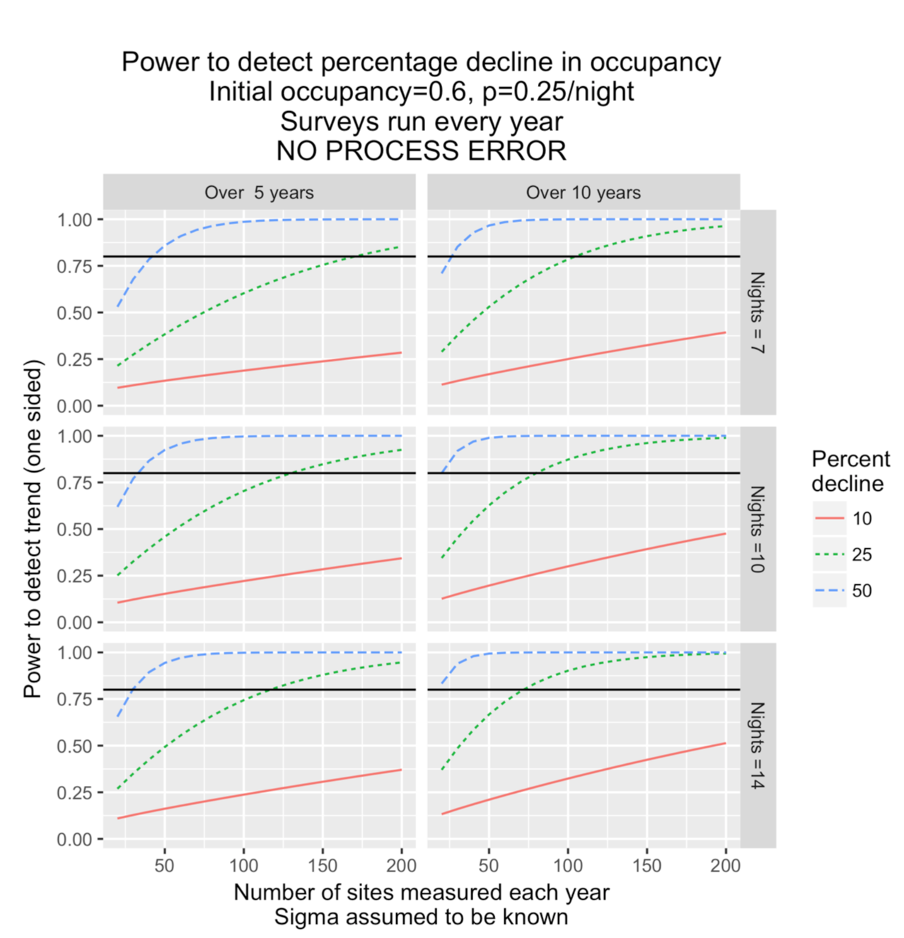

Power curves based on 2017 data from Schwarz (2018b) assuming separate sites measured each year and random occupancy.

#### Site Selection

As NSWO territories are expected to be around 400 ha (Waterhouse et al. 2017), Gwaii Haanas has been divided into a 2 x 2 km grid. This grid provides a useful tool for selecting sites for monitoring NSWOs.

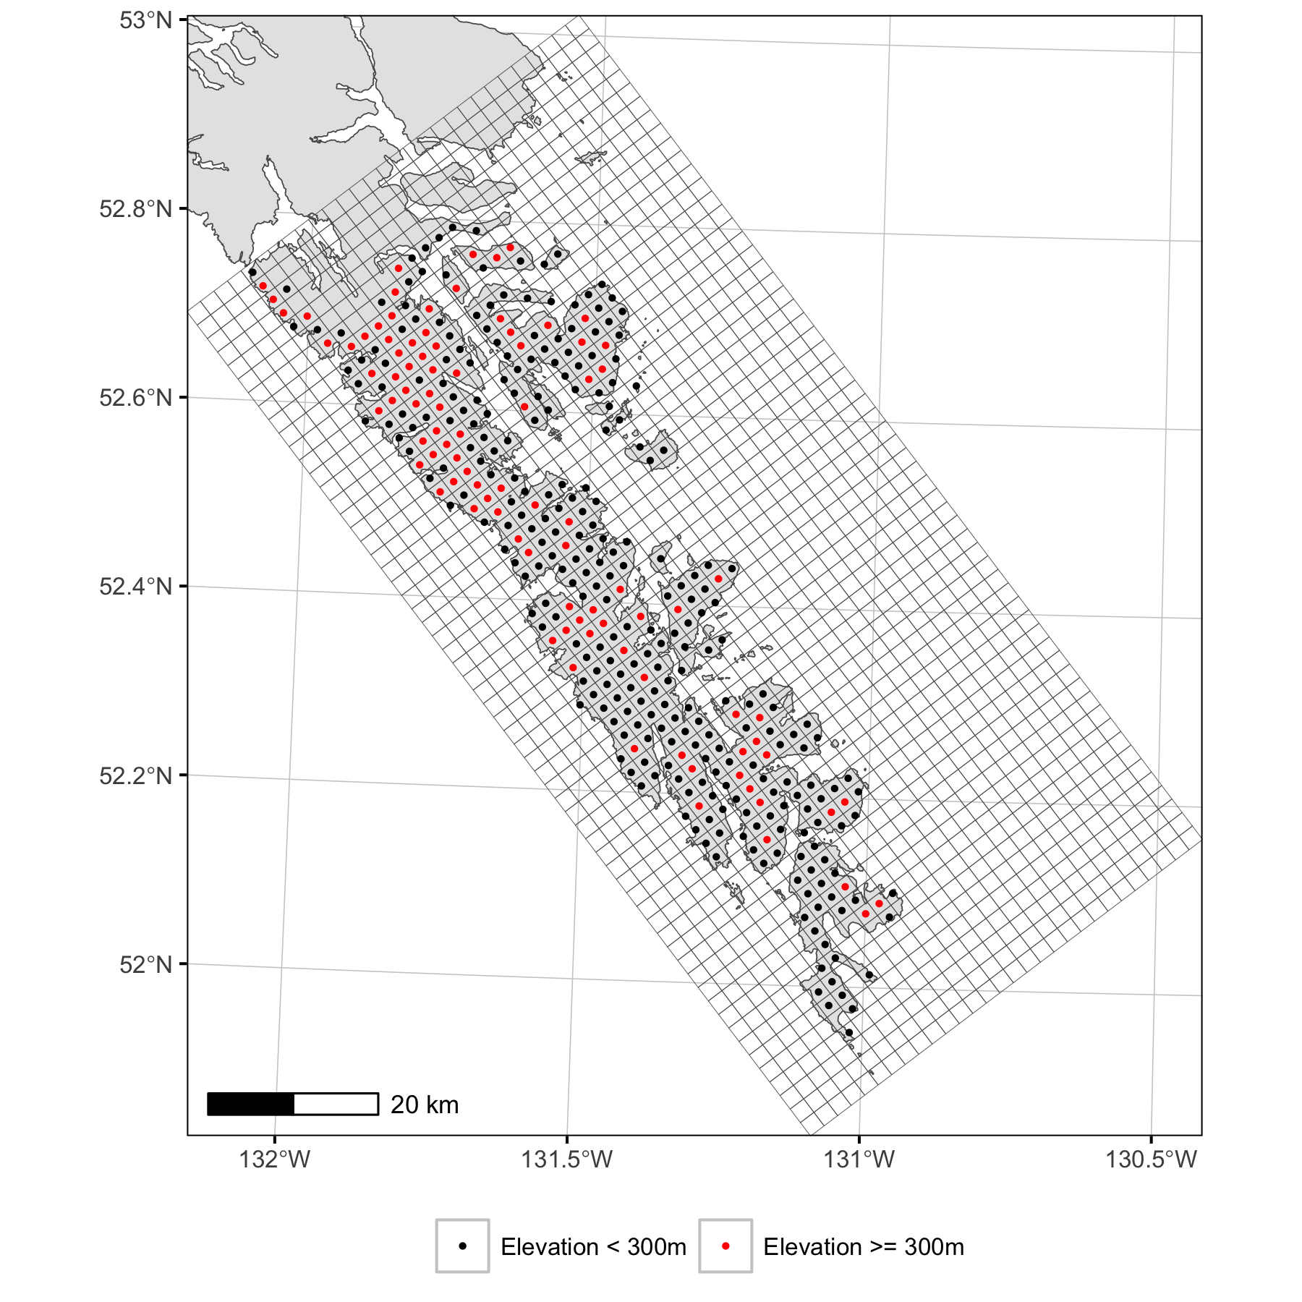

Figure 1. The 2 x 2 grid cells by elevation.

The optimal sampling design depends on the spatial population structure. If birds distribute randomly each year then it doesn’t matter which grid cells are selected. If birds tend to return to the same nesting cells then a panel design (in which 1/5 sites are swapped out each year) will increase the power (Schwarz 2018b). If birds prefer certain habitats then it is important to also stratify by habitat particularly if the strength of the preference is density-dependent. In this latter case, the number of sites would have to increased to allow the habitat specific responses to be teased apart.

##### Spatial Stratification

If birds in one region of Gwaii Haanas represent a demographically distinct population which may undergo different trends to those in other regions then it is important to also stratify by region. However, due to the relatively low statistical power (see below) and high costs of deployment, it is recommended to concentrate the bulk of the effort across a single population. An extensive literature review combined with professional judgement should be undertaken to determine which regions, if any, likely constitute demographically distinct populations. The region chosen should be accessible but unlikely to be influenced by habitat alteration at the park boundary. It is not necessary for the ARUs to cover the entire region of a single population. It is merely enough that they sample the range of habitats used by the population at at least 10 sites per habitat type. For more information see the Research Gaps sections.

The 2 x 2 km grid cells have been superclassified into twenty-four 12 x 12 blocks of cells which in the absence of any other information provides a useful device for ensuring spatial stratification of sites.

##### ARU Placement

Once a grid cell has been selected the ARU should be deployed at least 500 m from the boundary with other cells to reduce the probability of detections from NSWOs in adjacent cells. The precise location should be a quiet site (Schwarz 2018b), ie, away from a creek, that is unlikely to be disturbed by humans. Ideally the ARU should be deployed close to the centre point of each cell but this may not always be practical. The spatial coordinates should be recorded to ensure future deployments in each cell are at the same location.

#### Duration

The power analysis by Schwarz (2018b) indicates that there does not appear to be much benefit in running the detectors for more than 60 minutes (1 hours) in each period (morning and evening) if you continue to use 14 days of monitoring.

#### Recommendations

Based on the current findings it is recommended that for each demographic population of interest at least 10 ARUs are deployed in the cells of each habitat type for 14 days to record for 1 hour in each period. In other words if a single population with three habitat types is monitored then at least 30 ARUs would be deployed each year for an annual total of hours of data. This study design allows for the fact that habitat preferences may result in habitat specific density responses to changes in the population abundance (Shepherd and Litvak 2004).

### 2. Assure, 3. Describe and 4. Preserve

### Current System

Currently the raw .wav files are manually saved to hard drives with a duplicate set stored off-site. Staff members then listen to the .wav files up until the first call of interest and then enter the presence of the species into a large excel spreadsheet which archives all the data. As data continues to accrue, the reliance on a manual system will result in data losses, errors, and delays and increasing data management costs.

### Recommendations

Given the data-intensive nature of this long-term study which could over the course of twenty years accumulate over years of acoustic recordings at a collection cost in excess of a million dollars it is recommended that all the information including the raw .wav files is stored in a relational database. Relational database provide a natural framework for data quality assurance, the description of data in the form of metadata and the preservation of data integrity. They also facilitate data collection, discovery and integration. Although initially expensive the development of an automated workflow including report production is expected to result in substantial cost-savings and improved metrics. The database should be a secure, reliable, robust, distributed system. [postgreSQL](https://www.postgresql.org/about/) is recommended because as well as all of the above it is also open source.

It is also recommended that the program begin to use machine learning to process the sound files (see the Discover section below).

#### Collection

Although the ARU wav files are the primary data, their value is partially to severely reduced without the information in the database tables and columns. As such the data collection forms should be designed to ensure that all the required information is recorded in the correct format. Data collection should not be considered complete until all the information is successfully entered into the database.

#### Assure

Databases are designed to assure data quality through the use of data types, primary keys, foreign keys, indices and checks including missing values and data ranges. As a result, well designed database only allows internally consistent and biologically plausible data to be entered. Excel spreadsheets have limited data assurance capacities which are typically overridden by users.

#### Describe

Like excel spreadsheets, database columns and tables provide a straight-forward mechanisms to store metadata such as variable descriptions, units, time-zones and projections with the data itself.

#### Preserve

Database user settings ensure users are given the appropriate level of access and administrator privileges based on their roles and understanding of the database structure. Users can be provided with a range of different interfaces for interacting with the database including R functions and Graphical User Interfaces (GUIs) such as web pages and smart phone apps. Excel spreadsheets provide a single interface that allows users to unknowingly corrupt the base data.

### Database Structure

The following section provides an outline of key tables and columns in the relational database with primary key columns in **bold**. It should be considered a guide as opposed to a rigid prescription. In particular with an adequate upload interface the use of multi-column primary keys could be replaced by single column auto increment primary keys.

* GridCell Table
  + **GridCellNumber** INTEGER
  + GridCellLongitude REAL
  + GridCellLatitude REAL
* Species Table
  + Species TEXT IN (NSWO, MAMU, SOGR)
* Microphone Table
  + **MicrophoneNumber** TEXT
  + MicrophoneType TEXT
* ARUType Table
  + **ARUType** TEXT IN (SM2, SM3, SM4)
  + HighFrequency LOGICAL
* ARU Table
  + **ARUNumber** INTEGER
  + ARUType TEXT
* ARUDeployment Table
  + **ARUNumber** TEXT
  + **DateDeployed** DATE
  + MicrophoneNumber TEXT
  + GridCellNumber INTEGER
  + ARULongitude REAL
  + ARULatitude REAL
  + CrewDeployed TEXT
* ARURetrieval
  + **ARUNumber** TEXT
  + **DateDeployed** DATE
  + **DateRetrieved** DATETIME
  + CrewRetrieved TEXT
* ARURecording Table
  + **ARUNumber** TEXT
  + **DateDeployed** DATE
  + **StartDateTimeRecording** DATETIME
  + EndDateTimeRecording DATETIME
  + WavFile
* ARUProcessing Table
  + **ARUNumber** TEXT
  + **DateDeployed** DATE
  + **StartDateTimeRecording** DATETIME
  + Interpreter TEXT IN (CB, EL, Machine Learning Algorithm etc)
  + DateInterpreted DATE
  + EndDateTimeInterpreted DATETME (the recorded datetime that interpretation ended)
  + BackgroundNoiseLevel INTEGER
  + AudiblePrecipitation INTEGER
  + Species TEXT
* ARUDetection Table
  + **ARUNumber** TEXT
  + **DateDeployed** DATE
  + **StartDateTimeRecording** DATETIME
  + **Interpreter** TEXT
  + **DateInterpreted** DATE
  + **DateTimeDetected** INTEGER
  + **Species** TEXT
  + CallType TEXT
  + Individuals INTEGER

Tables to record crew members as well as microphone calibration and ARU battery replacement could also be added to facilitate equipment management.

## 6. Discover

The use of machine learning to automatically recognize and categorize acoustic calls is a rapidly evolving field that already has the potential to provide repeatable, fast, cost-effective wav file processing (Stowell and Plumbley 2014; Stowell et al. 2018). With the wav files readily accessible in a server-based database, it should be straightforward to secure collaborations with academic institutions to develop project-specific machine learning algorithms.

The use of machine learning would allow all calls to be processed not just the first call of a species. This in turn would allow analysis of the number of detections which may reveal additional information about behaviour and detection probabilities on shorter time scales. The use of machine learnings would also allow more detailed analysis of acoustic calls. For example Penone et al. (2018) demonstrate that acoustic data can provide useful inforamation about trends in body size in bats.

Analysis of all calls for all species could allow biodiversity trends to be estimated (Leinster and Cobbold 2012; Fairbrass et al. 2017).

## 7. Integrate

The acoustic data should be integrated with GIS-based habitat measures including elevation and coastal versus inland as well as times of sunrise and sunset and large-scale climatic indices (Ramey, Thorley, and Ivey 2018).

## 8. Analyze

The use of hierarchical Bayesian (Smith et al. 2014) occupancy models would readily account for spatial and temporal non-independence as well as truncated deployment times and variable detection probabilities. It would also allow the estimation of effect sizes (Bradford, Korman, and Higgins 2005) and the calculation of diversity profiles (Leinster and Cobbold 2012) if multiple species are considered. Hierarchical Bayesian models could start being developed for the current data although final analyses should wait until the data life-cycle has been fully developed to ensure the results are definitive.

## Research Gaps

There are a number of uncertainties that require addressing. These include habitat use above 300m, the receiver range and the demographic population structure.

Habitat use above 300 m can be explored through continued deployment of ARUs in the alpine. Information on habitat use would inform grid cell selection.

The receiver range can be quantified by

1. playing recording of calls of different species at a range of distances from receivers in different habitats and conditions.
2. deploying a network of receivers within the same grid cell and seeing which detect the same vocalizations.

Information on receiver range would inform site selection within grid cells.

The question of the demographic population structure could perhaps be addressed through analysis of the population genetic structure or tracking data. Failing that the best option may be to select an accessible region with diverse habitat types that likely falls within a single demographic unit.

## Recommendations

The key recommendations are as follows:

* store the data in a PostgreSQL database
* process the sound files using machine learning
* analyse the data using hierachical Bayesian occupancy models
* select grid cells using a panel design stratified by habitat
* deploy at a quiet site close to the centre point of each cell

## References

Bradford, Michael J, Josh Korman, and Paul S Higgins. 2005. “Using Confidence Intervals to Estimate the Response of Salmon Populations (Oncorhynchus Spp.) to Experimental Habitat Alterations.” *Canadian Journal of Fisheries and Aquatic Sciences* 62 (12): 2716–26. <https://doi.org/10.1139/f05-179>.

Fairbrass, Alison J., Peter Rennert, Carol Williams, Helena Titheridge, and Kate E. Jones. 2017. “Biases of Acoustic Indices Measuring Biodiversity in Urban Areas.” *Ecological Indicators* 83 (December): 169–77. <https://doi.org/10.1016/j.ecolind.2017.07.064>.

Leinster, Tom, and Christina A. Cobbold. 2012. “Measuring Diversity: The Importance of Species Similarity.” *Ecology* 93 (3): 477–89. <https://doi.org/10.1890/10-2402.1>.

Michener, William K., and Matthew B. Jones. 2012. “Ecoinformatics: Supporting Ecology as a Data-Intensive Science.” *Trends in Ecology & Evolution* 27 (2): 85–93. <https://doi.org/10.1016/j.tree.2011.11.016>.

Parks Canada Agency. 2011. “Consolidated Guidelines for Ecological Integrity Monitoring in Canada’s National Parks.”

Penone, Caterina, Christian Kerbiriou, Jean-François Julien, Julie Marmet, and Le ViolIsabelle. 2018. “Body Size Information in Large-Scale Acoustic Bat Databases.” *PeerJ* 6 (August): e5370. <https://doi.org/10.7717/peerj.5370>.

Ramey, Rob R., Joseph L. Thorley, and Alexander S. Ivey. 2018. “Local and Population-Level Responses of Greater Sage-Grouse to Oil and Gas Development and Climatic Variation in Wyoming.” *PeerJ* 6 (August): e5417. <https://doi.org/10.7717/peerj.5417>.

Schwarz, Carl James. 2018a. “Historical Occupancy Analysis for the Northern Saw-Whet Owl (NSWO) Monitoring Stations in 2012 Haida Gwaii,” March, 49.

———. 2018b. “Occupancy Analysis for the Northern Saw-Whet Owl (NSWO) Monitoring Stations in 2016 and 2017 Haida Gwaii,” March, 39.

Shepherd, Travis D, and Matthew K Litvak. 2004. “Density-Dependent Habitat Selection and the Ideal Free Distribution in Marine Fish Spatial Dynamics: Considerations and Cautions.” *Fish and Fisheries* 5 (2): 141–52. <https://doi.org/10.1111/j.1467-2979.2004.00143.x>.

Smith, Adam C., Marie-Anne R. Hudson, Constance Downes, and Charles M. Francis. 2014. “Estimating Breeding Bird Survey Trends and Annual Indices for Canada: How Do the New Hierarchical Bayesian Estimates Differ from Previous Estimates?” *The Canadian Field-Naturalist* 128 (2): 119–34. <http://www.canadianfieldnaturalist.ca/index.php/cfn/article/view/1565>.

Stowell, Dan, and Mark D. Plumbley. 2014. “Automatic Large-Scale Classification of Bird Sounds Is Strongly Improved by Unsupervised Feature Learning.” *PeerJ* 2 (July): e488. <https://doi.org/10.7717/peerj.488>.

Stowell, Dan, Michael D. Wood, Hanna Pamuła, Yannis Stylianou, and Hervé Glotin. 2018. “Automatic Acoustic Detection of Birds Through Deep Learning: The First Bird Audio Detection Challenge.” Edited by David Orme. *Methods in Ecology and Evolution*, November. <https://doi.org/10.1111/2041-210X.13103>.

Strasser, Carly, Robert Cook, William Michener, Amber Budden, and Rebecca Koskela. 2011. “Promoting Data Stewardship Through Best Practices.” In *Proceedings of the Environmental Information Management Conference*, 126–31.

Waterhouse, F. Louise, Frank I. Doyle, Laurence Turney, Berry Wijdeven, Melissa Todd, Carita Bergman, and Ross G. Vennesland. 2017. “Spring and Winter Home Ranges of the Haida Gwaii Northern Saw-Whet Owl ( *Aegolius Acadicus Brooksi* ).” *Journal of Raptor Research* 51 (2): 153–64. <https://doi.org/10.3356/JRR-16-48.1>.